**Download and install Matlab Compiler Runtime (MCR)**

* This is a freely available program you can download from the Matlab website:
* *http://nl.mathworks.com/products/compiler/mcr/*
* MCR allows users without a full version of Matlab to execute programs that have been precompiled for them. The only limitation with MCR is that you cannot view or modify any Matlab scripts.

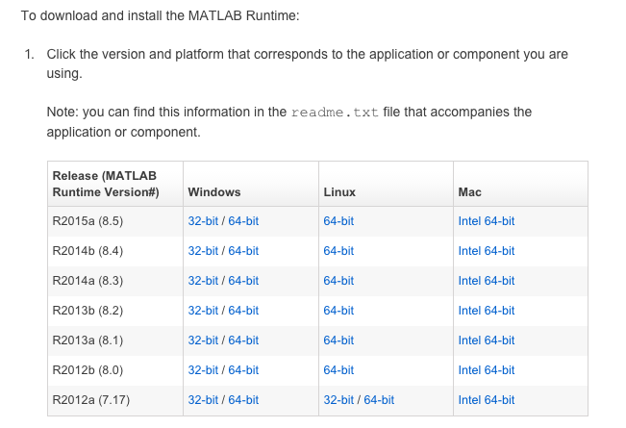

* You must download the version of MCR that corresponds to the version which was used to compiled the script you want to run. In this case, we compiled the program on **version** **2013a on Mac**, so you will download that version.
* After downloading, install MCR. It will be installed in the following folder (unless a different folder from the default was chosen)
  + */Applications/MATLAB/MATLAB_Compiler_Runtime/v81*

**Running particle motion analysis with MCR**

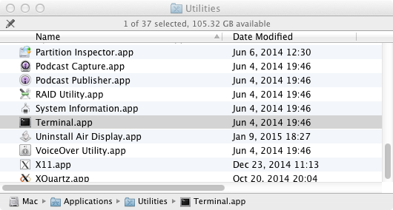

1. Open the **terminal** and set your working directory to anywhere you choose
   1. Your working directory will be where all your temporary files are stored
   2. Example, to change my directory to my desktop, I type in
      1. **cd ~/Desktop**



1. Find the locations of the compiled program files which were given to you (the particle motion analysis program) and the installation directory of MCR

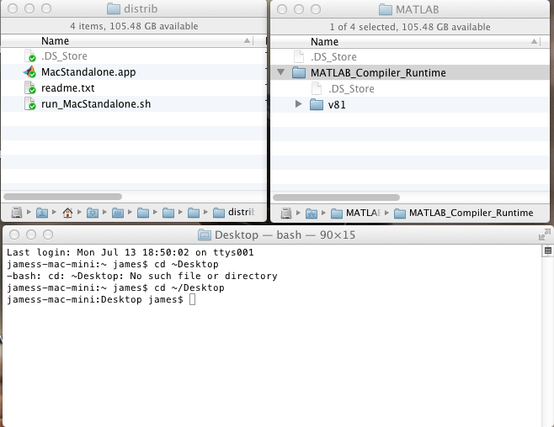

1. Drag the file ‘**run_MacStandalone.sh**’ into the terminal window. This will automatically copy the path of the file into the terminal. The result should look similar to the image below:

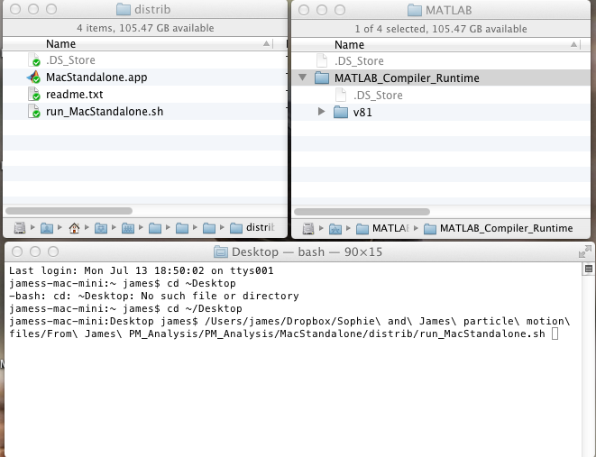

1. Now drag the folder named **v81** to the terminal. This will copy the location of the folder and paste it to the command line. The result will now look something like this:

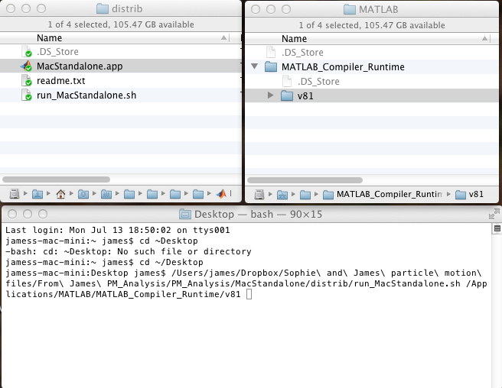

1. Now you can press enter and the particle motion analysis program will launch! The program **run_MacStandalone.sh** launches the program in a two step process
   1. Temporarily changes the system settings and tells your operating system the location of the MCR (this is why we had to copy the location of the MCR in the terminal)
   2. Runs the program from the terminal (make sure the program (**.app**) is always in the same folder as the **.sh** file!). This is important, as the terminal is where you will find all your output for the analysis you will be conducting.

